Created By : Yog Batra

https://www.linkedin.com/in/yog-batra-661798179/

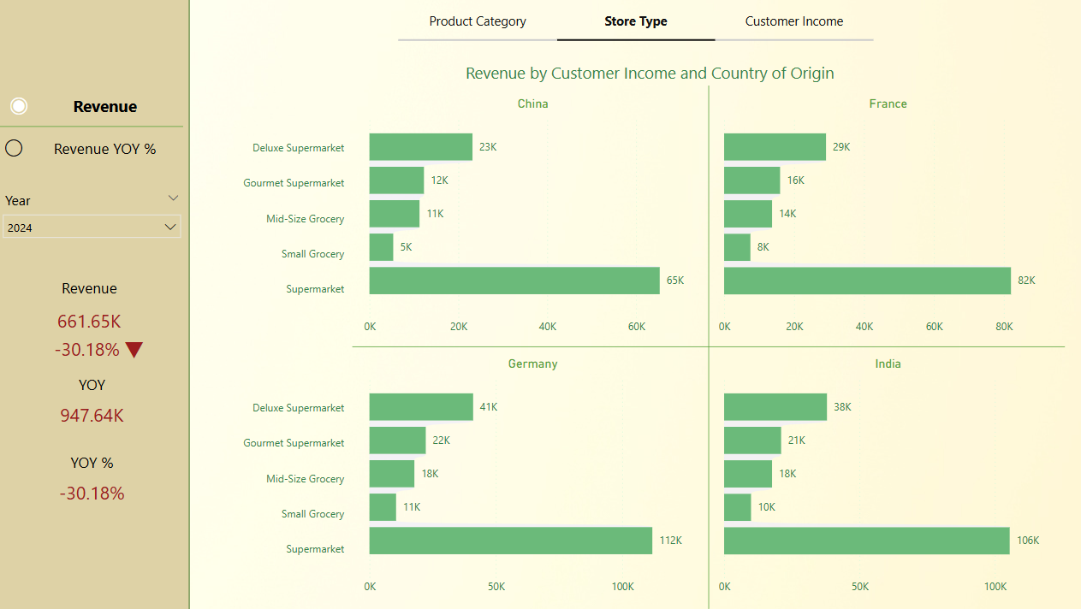

## **📊 Interactive Revenue Intelligence Dashboard (Fun with Fictional Stats)**

### **✅ Project Summary**

Built in Power BI as a personal side project, this dashboard explores revenue performance across four countries — **China, France, Germany, and India** — with the ability to toggle between **Store Type**, **Product Category**, and **Customer Income Group**.

What makes it fun?  
 👉 **All the data is entirely made up.** So the insights are as entertaining as they are “informative.”  
  
**🔄 Key Features**

* **Dynamic parameter control** to switch views by store type, income, or product.
* A **metric toggle** to view either:  
  + Total Revenue
  + Year-over-Year Growth Rate
* Sleek visual layout with horizontal bar charts for easy cross-country comparisons.
* Built using Power BI’s **DAX, slicers, and clean UX design** principles.

### **🤯 Fun “Insights” That Aren’t Real**

* Germany’s supermarkets dominate, selling more than France and China combined.
* France’s high-income customers love their gourmet supermarkets — .
* A -30.18% YoY decline sounds alarming, but don’t worry — the economy of this imaginary world is *resilient.*

### **🌱 What I Learned (Besides How to Make Up Stats)**

* Built parameter-based visuals to switch dimensions on the fly.
* Practiced advanced DAX measures and interactive UX in Power BI.
* Learned that **designing a dashboard is as much about storytelling as it is about data.**
* Had fun using *fake numbers* to create a dashboard that *feels real*.

**TAKEAWAY : EVEN THOUGH THE DATA IS FAKE, THE CHALLENGES WERE REAL**